Effects of the Black Death — source response
Teacher guidelines
Year 8 | Australian Curriculum  History
Students will respond to source documents before using evidence and historical terms to explain social changes in medieval Europe as a result of the Black Death.
Context for assessment
This assessment encourages students to understand the concept of cause and effect through the use of historical sources. The context of social changes resulting from the Black Death in 14th-century Europe will develop students’ understanding of the concepts and knowledge necessary to answer the key inquiry question: How did societies change from the end of the ancient period to the beginning of the modern age? Sources are included in the assessment so that teachers will not need to spend time teaching the content for the identified depth study content descriptions. If the suggested learning experiences and the remaining content descriptions for this depth study have been studied, students will be well positioned to complete the assessment.
For further information about supervised assessments and implementing the Australian Curriculum — History, see Assessment advice and guidelines for History, available at: www.qsa.qld.edu.au/13659.html.

© The State of Queensland (Queensland Studies Authority) and its licensors 2012. All web links correct at time of publication.


Link to  Make judgments |  | Year 8 Australian Curriculum History
Understanding | Historical Knowledge and Understanding | Expanding Contacts  The Black Death in Asia, Europe and Africa (14th century plague)  The effects of the Black Death on Asian, European and African populations, and conflicting theories about the impact of the plague. (ACDSEH071)  Other immediate and long-term effects of the Black Death, including labour shortages, peasant uprisings, the weakening of feudal structures, and increased social mobility. (ACDSEH072)
Skills | Historical Skills | Historical Skills  Analysis and use of sources  Locate, compare, select and use information from a range of sources as evidence. (ACHHS153)  Draw conclusions about the usefulness of sources. (ACHHS154)  Chronology, terms and concepts  Use historical terms and concepts. (ACHHS149)  Explanation and communication  Develop texts, particularly descriptions and explanations that use evidence from a range of sources that are acknowledged. (ACHHS156)
Achievement standard, with assessed areas highlighted
By the end of Year 8, students recognise and explain patterns of change and continuity over time. They explain the causes and effects of events and developments. They identify the motives and actions of people at the time. Students explain the significance of individuals and groups and how they were influenced by the beliefs and values of their society. They describe different interpretations of the past.
Students sequence events and developments within a chronological framework with reference to periods of time. When researching, students develop questions to frame an historical inquiry. They analyse, select and organise information from primary and secondary sources and use it as evidence to answer inquiry questions. Students identify and explain different points of view in sources. When interpreting sources, they identify their origin and purpose, and distinguish between fact and opinion. Students develop texts, particularly descriptions and explanations, incorporating analysis. In developing these texts, and organising and presenting their findings, they use historical terms and concepts, evidence identified in sources, and acknowledge their sources of information.
 |  | Source: ACARA, The Australian Curriculum v 3.0, www.australiancurriculum.edu.au

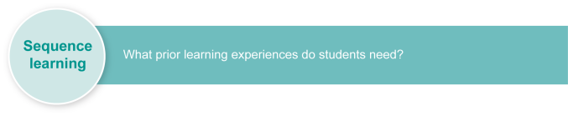
Suggested learning experiences |  | Curriculum links
Learning topic-specific vocabulary and knowledge
Play games to learn or review new concepts and vocabulary, including revolution, feudal system, feudalism, serfs, subsistence, pestilence, epidemic, villein, gentle folk, Jacquerie, serf, noble.
Games could include:
- Memory — follow the traditional card-game rules using cards with a range of words and definitions printed on them (2–4 players)
- Balderdash — give each student a card that contains a word and its correct definition. The student must tell others the word and three definitions (one correct, two incorrect). Peers must use general knowledge, inference and clues to determine which definition is correct and which two are incorrect
- Pictionary — issue students with a list of words and definitions. Each student must sketch word components or create a cartoon that illustrates the definition without using the actual word. Peers must guess the word and offer a definition.
Research, discuss and read about topic-specific knowledge, including the:
- geography of Europe leading up to the 14th century
- social, political and economic (including trade) perspectives of Europe leading up to the 14th century
- role of the church in the medieval period
- feudal system and social hierarchy/organisation
- lifestyles of peasants compared to nobles
- nature of the Black Death (cause, symptoms, transmission, immediate effects on society, responses of different groups in society)
- political, medical and spiritual responses to the plague.
Use primary and secondary sources (see Australian Curriculum content descriptions ACDSEH015, ACDSEH069 and ACDSEH070).
Refer to Appendix A for sample sources and Appendix B for practice questions.
Discuss the concept of cause and effect by examining how events, trends or ideas emerge and unfold throughout history, e.g. Olympic Games, colonisation of Australia, White Australia policy, suffragism, globalisation.
Understanding and analysing historical sources
Practise note-taking skills when encountering historical information to:
- show how one event or idea can create flow-on effects or a chain reaction of other events or ideas
- group effects into immediate, short term and long term.
Revisit prior learning, understanding of, and strategies for higher-order thinking skills, e.g. comparison, prediction, summarising, evaluating, classifying in relation to analysing a range of sources.
Interpret and analyse different types of sources, e.g. graphs, maps, diary accounts, artwork, speeches, literature. Refer to Appendix B: Practice questions for use with Appendix A: Background information for the Black Death.
Identify and use a range of comprehension strategies to understand sources:
- on a literal level (information found within a text)
- on an inferential/interpretative level (information that is not found on the surface and must be drawn together from clues)
according to the origin and purpose of the source, the historical context of the source, and supporting topic knowledge.
Practise asking questions that a source does/does not answer or identifying the information it does provide (without any inferring).
Consider the concept of a source’s usefulness. Practise evaluating how a source might be useful (for the information it can provide to historians/students) or limited (what or whose information or point of view it does not provide). Interrogate sources with a focus on the creator, time of creation, historical context and the form of the source.
Experiment with a range of strategies to interpret, corroborate and synthesise multiple sources (such as those seen in the source sheet), including:
- constructing lotus diagrams (graphic organiser) for common themes/issues/queries in and about sources
- completing a PPEST grid (people/perspectives, places, events, sources, time) to consider how balanced and comprehensive a range of sources might be. Note what is covered in the sources under each heading, then identify what might be needed to provide a more balanced or comprehensive view.
- using Venn diagrams to look at what is corroborated by sources.
Using historical sources and terms in explanations
Experiment with selecting different types of evidence to evaluate what is most effective to support your explanation.
Incorporate evidence from sources into your responses and acknowledge sources of evidence (by referring to an author, document, artefact or specific source from a handout).
Draft and edit own and others’ responses to examine how clear, reasoned and well-supported explanations are constructed.
Create a historical glossary or Word Wall for your own and others’ writing.
Practise using and annotating historical terms in your writing.
General capabilities | Literacy Numeracy ICT capability Critical and creative thinking  Ethical behaviour Personal and social capability Intercultural understanding
Cross-curriculum priorities | Aboriginal and Torres Strait Islander histories and cultures  Asia and Australia’s engagement with Asia Sustainability

Resources
- Aboriginal and Torres Strait Islander perspectives
- Diversity of learners
- Appendix A Background information to the Black Death
- Appendix B Practice questions
- Appendix C Reference list for sources
- Assessment-related resource Effects of the Black Death (PowerPoint)
- Assessment-related resource Practice questions (Word document)

Web links

Primary sources
Historical map of medieval Europe in the 13th century. History for the Relaxed Historian, New Mexico, Medieval Europe 13th century, www.emersonkent.com/map_archive/europe_13th_century.htm.
Primary sources from a range of historical periods. Internet History Sourcebooks Project, Fordham University, New York, Internet Medieval sourcebook, www.fordham.edu/Halsall/sbook.asp.

Primary sources on aspects of medieval life. Eyewitness to History, Ibis Communications, New York. The Middle Ages and Renaissance, www.eyewitnesstohistory.com/mefrm.htm.

Secondary sources
Aspects of life in medieval Europe (designed for students). Mr Donn.org, USA. The Middle Ages for kids, http://medievaleurope.mrdonn.org.
Aspects of life in medieval Europe. Medieval-life.net, Wyoming, USA, Medieval European history www.medieval-life.net/history_main.htm.
Biologist’s information blog about Black Death in India and China. Michelle Ziegler, Contagions: Thoughts on historic infectious diseases, “Did India and China escape the Black Death”?, http://contagions.wordpress.com/2011/11/26/did-india-and-china-escape-the-black-death.
Description of Black Death’s impacts as it spread across Britain. BBC History, England. Black Death, www.bbc.co.uk/history/british/middle_ages/black_01.shtml.
History through art. Bridgeman Art Library, England. Art, culture & history images (select “Browse” then “History”), www.bridgemanart.com/browse/category/History/1260.
History website links. The National Centre for History Education, Australian Government, Australia, Hyper history, www.hyperhistory.org/index.php?option=displaypage&Itemid=226&op=page.
Long-term impacts of the Black Death. BBC History, England. Black Death: Political and social changes, www.bbc.co.uk/history/british/middle_ages/blacksocial_01.shtml.

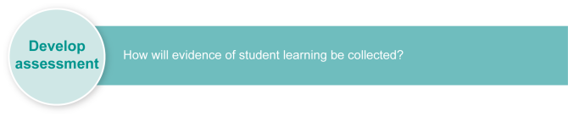
Preparing
The use of sources and contextual notes within the Student booklet means that there is no need to teach the content knowledge for ACDSEH071 and ACDSEH072.
This reduces time spent in class covering all content descriptions for this depth study. The suggested learning experiences ensure students are familiar with the skills needed to engage with the assessment.
Ensure that this assessment is completed after studying events, experiences and people leading up to, and during, the Black Death (see Australian Curriculum History content descriptions ACDSEH015, ACDSEH069 and ACDSEH070).

Implementing
As an alternative to the Student booklet, this assessment includes a PowerPoint of the sources and an accompanying Word document with the questions.
Time | Student role | Teacher role
Section 1. Using a source
Teacher discretion | As a class, read and listen to the text in  Section 1.  Complete Q1–9 individually. | The assessment requires students to understand the sources and supporting text to respond. To ensure understanding, read all texts as a class. (Students’ literacy is not being assessed.)  Clarify terms as needed for students.  Determine the support that will be provided to students to re-read or comprehend the sources and to ensure equity, e.g. include note-taking time for students who need extra processing time, or construct cloze sentence starters to help students articulate understanding.
Section 2. Identifying cause and effect
Teacher discretion | As a class, read and listen to the text in  Section 2.  Complete Q10–12 individually. | Monitor student responses to ensure equity and the conditions required for making reliable judgments.
Section 3. Explaining the effects of the Black Death
Teacher discretion | As a class, read and listen to the text in  Section 3.  Complete Q13–14 individually. | Monitor student responses to ensure equity and the conditions required for making reliable judgments, e.g. adapting questions such as Q13 so students respond by creating and verbally explaining a drawing.


Finding the evidence

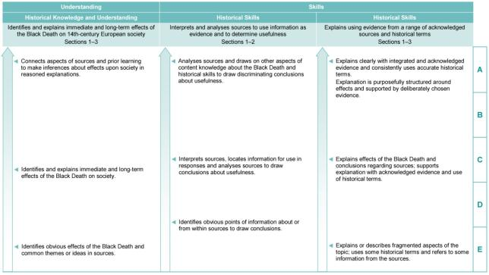
Look in Section 1 of the Student booklet for evidence of:
- using historical terms and concepts (Q1–9)
- developing explanations that incorporate and acknowledge evidence (Q2a, 3, 6, 8, 9).
Look in Section 2 of the Student booklet for evidence of:
- using historical terms and concepts (Q10–12_
- developing explanations that incorporate and acknowledge evidence (Q12).
Look in Section 3 of the Student booklet for evidence of:
- identifying historical terms and concepts (Q13)
- using historical terms and concepts (Q14)
- developing explanations that incorporate and acknowledge evidence (Q14)
- developing explanations that are clearly organised in introductory remarks, paragraphing and summary statements (Q14).
Look in Section 1 of the Student booklet for evidence of:
- using sources to identify information about medieval Europe (Q1, 5)
- using information from within sources or about the origin of sources to describe, explain or predict (Q2a, 4, 6, 7)
- drawing a conclusion about the usefulness of a source (Q3, 8, 9)
- including other aspects of understanding or skills to draw a conclusion (Q2c, 4, 8, 9).
Look in Section 2 of the Student booklet for evidence of:
- using information from within sources or about the origin of sources to explain or predict (Q10, 11, 12).
Look in Section 1 of the Student booklet for evidence of:
- identifying aspects of 14th century European society (Q1)
- explaining and inferring about the effect of the Black Death on populations (Q2, 7)
- identifying and explaining immediate and long-term effects of the Black Death (Q4, 5, 6).
Look in Section 2 of the Student booklet for evidence of:
- identifying and explaining how the effects of the Black Death changed society (Q10,11)
- explaining social structures in medieval Europe and how they would be affected by the Black Death (Q12).
Look in Section 3 of the Student booklet for evidence of:
- understanding the immediate and long-term effects of the Black Death — Q14.


Evaluate the information gathered from the assessment to inform teaching and learning strategies.

Use feedback to respond to student work and identify possible approaches for improvement.
At a D level, student explanations might be characterised by evidence that is not relevant or supportive, lacks detail in reasoning and has structural flaws that impede clear communication.
Specific feedback to progress student understanding could direct them to:
- consider what evidence in the source most closely sounds like and supports their reasoning
- try using simple sentences to express and unfold their understanding at the draft stage, then combine ideas and information to create more fluid and clear explanation
- use a structured approach to their writing such as TEEL (topic sentence, explanation, evidence, link to topic or next paragraph).
At a B level, student explanations might be characterised by evidence that is not clearly linked to, and incorporated into, their explanation. It may also lack expertise in acknowledging sources within the explanation.
Specific feedback to progress a student’s understanding could direct students to:
- make a practice of articulating the way the evidence justifies, proves or supports their explanation
- experiment with their sentence structure to see how they can fluidly incorporate a quote or piece of evidence into their reasoning
- seek out different models of acknowledging a source and making the source a powerful part of the supporting evidence. For example:
- moving from a C level where students may write “The French nobles ‘wiped them out wherever they found them’ (Source H)”
- moving towards a B level, where students may write “As seen in Source J, the famous chronicler Froissart described the merciless way the ‘nobles wiped them out wherever they found them’”.

Background information to the Black Death
Source 1
Illustration from the 14th century Grimani Breviary, showing typical activities during the month of September
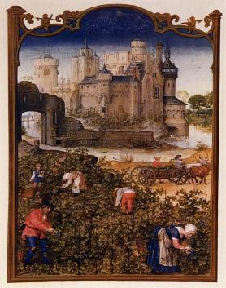 | Europe in the 1300s had just been through a tough time — there had been a couple of famines where there was little food and it made the poor people (peasants) poorer, while the rich people (nobles) built higher and thicker walls on their castles. They may have lived in the same country, but the peasants and the nobles lived in two different worlds.  Imagine if you never left the suburb or town you live in now — peasants were born, lived and died in the same area.

Source 2
Organisation of society according to the feudal system during the medieval period in Europe
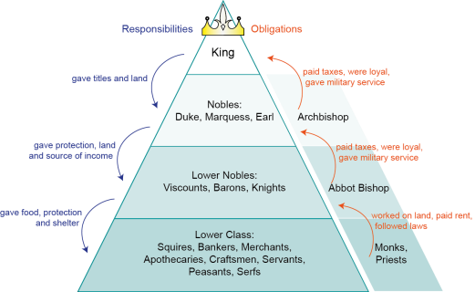 | The graphic  organiser of a pyramid shows the organisation of society in the medieval period — known as the feudal system. A person was born into a particular class and could not usually move upwards in society. It also shows who had power over others and represents the approximate percentage of the population in each class.
Source 3
Map showing the directions and speed of the Black Death as it moved across Europe
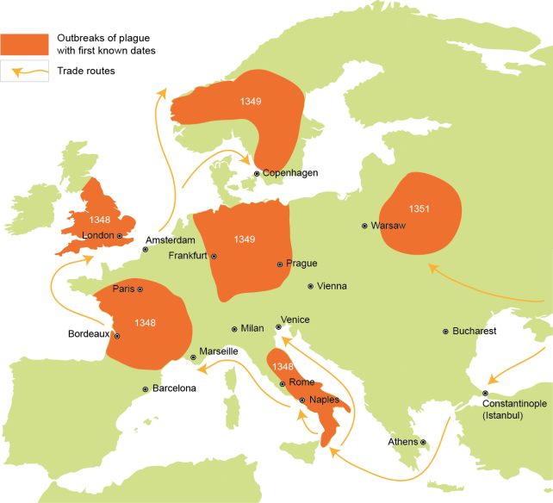
The Black Death travelled across the globe, helped by the trade routes and the often crowded living conditions. People, as well as news, travelled slower than we do today — transport was by ship, carts drawn by horses or cattle, or by “foot falcon” (walking). Often the news of this terrible plague was brought to a town by people who also brought the disease. By 1348, English nobles had heard about the terrible deaths across the sea but were hoping that they would be spared by God and by their distance from the continent. The feudal system ensured that the peasants, living quiet lives according to the laws of the nobles, kept working in the fields with no idea of the horrors they were about to endure.

Source 4
Excerpt from Giovanni Boccaccio’s The Decameron, written in the 14th century
“Such was the terror this [the Black Death] caused that seeing it take hold in a household, as soon as it started, nobody remained ... No doctors were to be found, because they were dying like everybody else ... Sons abandoned fathers, husbands wives, wives husbands, one brother the other, one sister the other.”
Source 5
Graph showing world population growth — note that the Black Death is the only noticeable event to actually reverse the growth trend
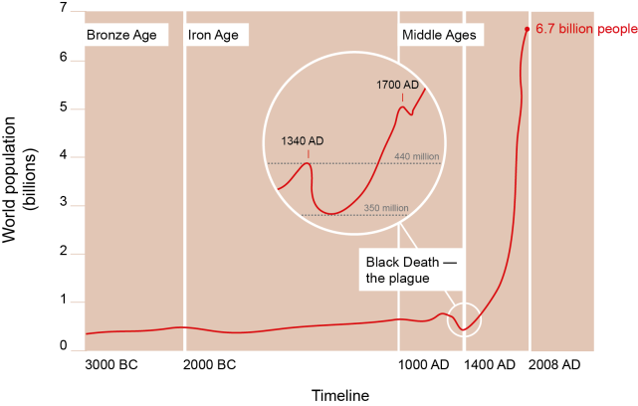
The Black Death claimed anywhere from one third to half of the population in Europe. Some experts think that one fifth of the world population at the time were killed, while some argue that it was actually one third of the population. The massive death toll meant that the way society was organised had to change if life was to go on. Look around — imagine if every third or fourth person in your class, family, sports club or town suddenly died? What problems might happen with basic aspects of life such as food, clean running water, shelter, electricity and medicine?
After the Black Death, social structures weakened and changed — partly because wealth moved around as people inherited from dead relatives and partly because as time went on the peasants became more valuable to the nobles for the work they did.

Practice questions
Use these practice questions to interpret and analyse the sources in Appendix A.
Source 1
- Why might images have been used in the place of writing in the medieval period?
- If the image was set inside the castle, what activities might we see people doing?
Source 2
- Design and annotate a graphic organiser to show how society is organised today.
- Which level of the feudal pyramid would you have preferred to be part of in medieval Europe? Explain your reasoning.
Source 3
- Using information from the source, explain (in writing or verbally) the movement of the disease across Europe.
- Predict why it might have taken longer to appear in Eastern Europe.
Source 4
- What effects of the Black Death does the writer describe? Use evidence from the source.
- How would medieval society have been affected by the events described in the source?
Source 5
- Which questions does this source answer?
- What predictions can you make from examining it?

Reference list for sources

Sources in the Student booklet
Source A/1
Grimani Breviary: The Month of September 1490–1510, digital image of illumination on parchment, Wikimedia Commons, http://commons.wikimedia.org/wiki/File:15th-century_unknown_painters_-_Grimani_Breviary_-_The_Month_of_September_-_WGA15783.jpg.
Source B/5
Created by the QSA.
Source C
Matteo Villani 1348, 14th-century description of the Black Death in Florence in Cronica Universale, Alchemedia, http://alchemipedia.blogspot.com/2009/11/matteo-villani-chronicler-florence-d.html.
Source D
Statute of Laborers 1351, The Avalon Project, Yale University Law School, http://avalon.law.yale.edu/
medieval/statlab.asp.
Source E
Henry Knighton 1337–1396, History of England, TheMiddleAges.net: www.themiddleages.net/life/
witness.html.
Source F
Munro J 2004, wages data derived from Before and after the Black death: Money, prices, and wages in fourteenth-century England, University of Toronto, http://mpra.ub.uni-muenchen.de/15748.
Source G
John Ball 1381, from “Sermon before the English Peasant Revolt 1381” quoted in J Froissart Chroniques 1369–1400, Ken Pennington, Catholic University of America, http://faculty.cua.edu/pennington/
churchhistory220/lectureten/johnball.html.
Source H
Jean Froissart, Chronicles (1369–1400), trans. G Brereton, Harmondsworth, Penguin, 1968, pp.151–155.
Source I
Defeat at Meaux 1358, illustration, digital image of illumination on parchment from Froissart’s Chronicles, Wikimedia Commons, http://commons.wikimedia.org/wiki/File:Jacquerie_meaux.jpg.

Sources in Appendix A: Background information to the Black Death
Source 2
Created by QSA.
Source 3
Created by QSA.
Source 4
Givanni Boccaccio c1353, The Decameron, trans. John Florio 1620, eBooks Adelaide, University of Adelaide, South Australia, http://ebooks.adelaide.edu.au/b/boccaccio/giovanni/b664d/.

Notes

Aboriginal and Torres Strait Islander perspectives Teachers are encouraged to use Aboriginal and Torres Strait Islander knowledge, histories and cultures in planning all aspects of their curriculum. Both QSA and ACARA provide useful resources: - QSA — Indigenous perspectives support materials: www.qsa.qld.edu.au/3035.html - ACARA — Aboriginal and Torres Strait Islander histories and cultures: www.australiancurriculum.edu.au/CrossCurriculumPriorities/Aboriginal-and-Torres-Strait-Islander-histories-and-cultures.
Diversity of learners Students in Australian classrooms may have diverse needs that are shaped by individual learning histories and abilities as well as cultural language backgrounds and socioeconomic factors. Both QSA and ACARA provide useful resources: - QSA — Special educational needs: www.qsa.qld.edu.au/691.html - ACARA — Diversity of learners: www.australiancurriculum.edu.au/Science/Diversity-of-learners.
Matching evidence to a descriptor This assessment uses a continua-style GTMJ where descriptors are placed along a continuum within each column and teachers make an A to E judgment around student responses. For each column in the GTMJ: - begin at the bottom of the continuum - consider all descriptors on the continuum - make an on-balance judgment for that column by choosing the position on the continuum that best matches the evidence. Make an on-balance judgment to arrive at an overall grade by considering the judgments recorded for each column and the relative significance of each column to the stated purpose of assessment.
Evaluate the information gathered from the assessment to inform teaching and learning strategies. Involve students in the feedback process. Give students opportunities to ask follow-up questions and share their learning observations or experiences. Focus feedback on the student’s personal progress. Emphasise continuous progress relative to their previous achievement and to the learning expectations — avoid comparing a student with their classmates. For guidance on providing feedback, see the professional development packages titled Seeking and providing feedback in the Resources section of the Assessment Bank: https://qcar.qsa.qld.edu.au/assessmentbank.

